**100 Series**

From 3 to 23 tm class 3T technology represents tomorrow’s technology today and is a new design philosophy adopted by the 100 series cranes aimed at more capacity, less weight and competitive price. Strong Light Competitive

**100 Series**

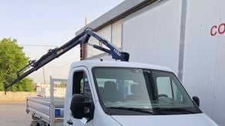

**103**

Max. Lifting capacity (kg)

850

Lifting Moment Class (tm)

3

Max. Extension reach (m)

6.75

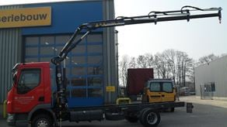

**105**

Max. Lifting capacity (kg)

1350

Lifting Moment Class (tm)

4

Max. Extension reach (m)

7.01

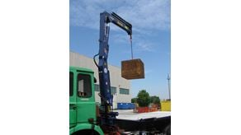

**108**

Max. Lifting capacity (kg)

2230

Lifting Moment Class (tm)

8

Max. Extension reach (m)

7.61

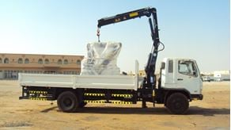

**111**

Max. Lifting capacity (kg)

2460

Lifting Moment Class (tm)

10

Max. Extension reach (m)

9.17

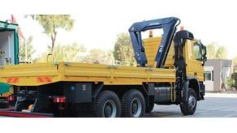

**115**

Max. Lifting capacity (kg)

5950

Lifting Moment Class (tm)

14

Max. Extension reach (m)

9.18

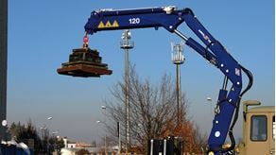

**120**

Max. Lifting capacity (kg)

8140

Lifting Moment Class (tm)

19

Max. Extension reach (m)

9.23

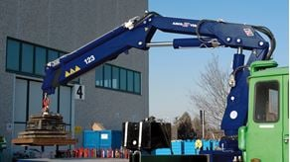

**123**

Max. Lifting capacity (kg)

8680

Lifting Moment Class (tm)

21

Max. Extension reach (m)

9.23